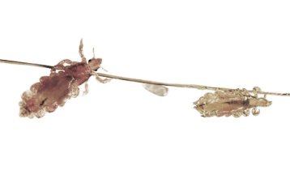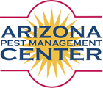

**It’s FREE!**

**Save the Date**

**Integrated Pest Management (IPM) Workshop**

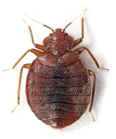This workshop is a part of the Stop School Pests Initiative: Enabling Schools to Reduce Risks Associated with Pests and Pest Management Practices

**6 Division of Pest Management CEs will be provided**

**Date: *ADD DATE HERE***

**Venue: *ADD VENUE AND ADDRESS HERE***

|  |
| --- |
| **The purpose of this workshop is to provide information on:**   * List learning objectives here!    **This workshop is for:**   * Add list of relevant groups here! |

**Pre-Registration is required for planning purposes! To register please email NAME, EMAIL ADDRESS HERE**

